78. What Many Don’t See

Sun streams down from bright blue skies and the earth is dry and warm. An eccentric old man is leading his work team on the construction site. He has invested lots of money in all the resources needed in this major project. The bizarre superstructure seems out of place amongst the surrounding properties. He intends to migrate to a distant country, and to farewell all his neighbours are familiar and comfortable with.

You are not unlike this patriarch of old. You are building lives and investing in what can’t yet be seen, namely the adult lives of your students. You persist with young people that other people have given up on. You do this because your eye is on more than today, and what is evident at hand. You are building them for a destination you don’t know which lies ahead in the future. To your critics, your practices and beliefs seem like quaint superstitions. They mocked Noah; they will scoff at your efforts too. A deluge might not be the mechanism which carries the students to their assigned destinations and destinies, but they are surely to disperse far from your campus. Noah was vindicated for his faith, and his investment of energies into a project that was for a distant place, despite the evidence that no water was available to float his boat. As a transient, like him, you have your eye on your true home and you are helping students to build vessels and lifestyles that will get them there.

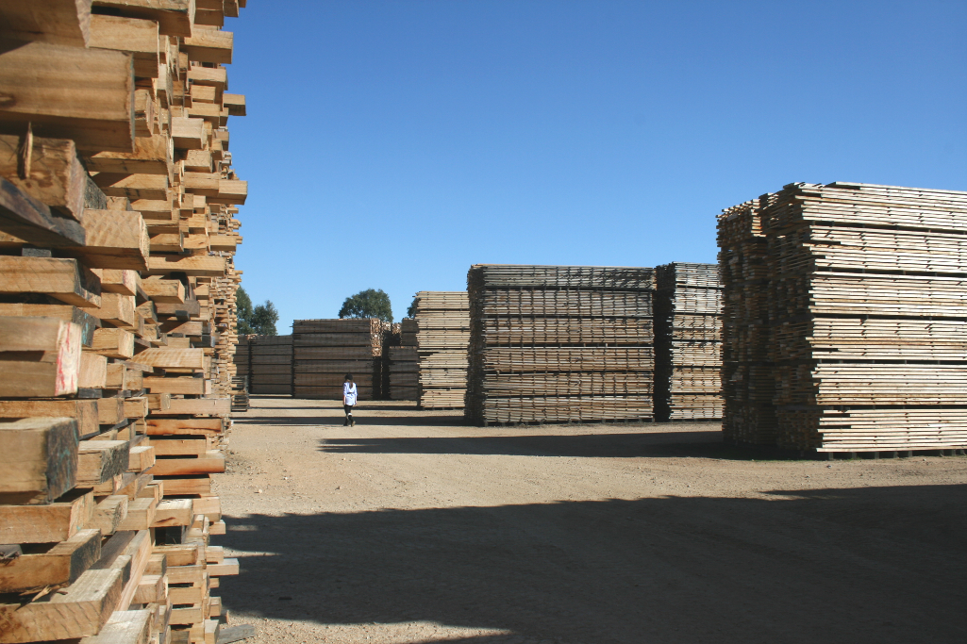

But Noah was different. God liked what he saw in Noah Genesis 6:8

By faith, we see the world called into existence by God's word, what we see created by what we don't see. Hebrews 11:3

By faith, Noah built a ship in the middle of dry land. He was warned about something he couldn't see, and acted on what he was told. The result? His family was saved. His act of faith drew a sharp line between the evil of the unbelieving world and the rightness of the believing world. As a result, Noah became intimate with God. Hebrews 11: 7

But they were after a far better country than that - heaven country. You can see why God is so proud of them, and has a City waiting for them. Hebrews 11:16

Through acts of faith, they toppled kingdoms, made justice work, took the promises for themselves Hebrews 11: 33

